

ISO 9001:2008 Certified Institute

**JAVA INSTITUTE FOR ADVANCED TECHNOLOGY**

Department of Examinations

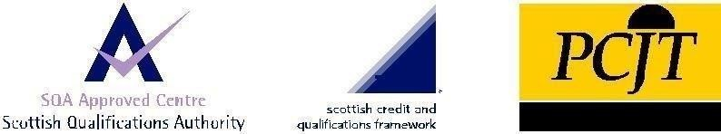

|  |  |
| --- | --- |
| COURSE(S) – (LEADING TO) | PROFESSIONAL HIGHER DIPLOMA IN SOFTWARE ENGINEERING |
| ASSIGNMENT STARTING DATE | 16th May 2020 |
| ASSIGNMENT CLOSING DATE | 23rd May 2020 |
| UNIT NAME | PROJECT MANAGEMENT |
| UNIT ID | HF2N 04 |
| ASSIGNMENT ID | HF2N 04/AS/12 |
| DESCRIPTION | Multiple choice question paper (Individual Assignment) |

|  |  |
| --- | --- |
| NAME : | KANDAGE DON ISHAN VIHANGA VIMUKTHI  .................................................................................................................................... (BLOCK CAPITALS) |
| NIC : | 960263812v  .................................................................................................................................... |
| SCN NO : | 177646148  .................................................................................................................................... |

Java Institute for Advanced Technology Sri Lanka

1. The process of Control Procurements falls under which process group
   1. Planning
   2. Closing
   3. Monitoring and Control
   4. Executing
2. Sam Consultancy is planning to buy ten desktops for $1500 each from a leading computer store. Which type of contract will get signed in this case?
   1. Purchase Order
   2. Cost plus Fee
   3. Fixed cost
   4. Time and Material
3. The process of managing procurement relationships, monitoring contract performance, and making changes as appropriate is called
   1. Plan Procurement Management
   2. Control Procurements
   3. Close Procurements
   4. Conduct Procurements
4. Which contract type places the most risk on the seller?
   1. Cost plus percentage fee
   2. Cost plus incentive fee
   3. Cost plus fixed fee
   4. Fixed price plus incentive fee
   5. Firm fixed price
5. What is the last item a project manager must do to finalise the project closing?
   1. Reassign the team
   2. Contract completion
   3. Archive the project records
   4. Complete lessons learned
6. For the processes in the Project Procurement Management,
   1. Plan Procurement Management
   2. Control Procurements
   3. Conduct Procurements
   4. Close Procurements

The correct sequence is:

a.

1-2-3-4

b. 1-3-2-4

c. 1-4-3-2

d. 3-1-2-4